

**Learning in the Loo**

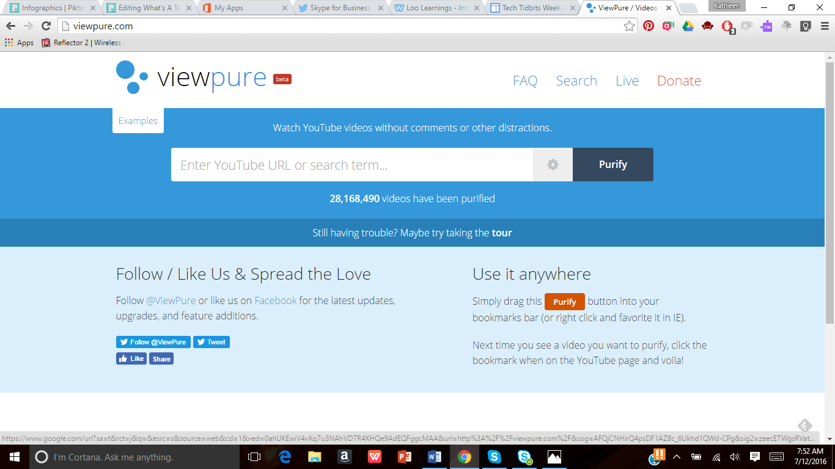

Showing a YouTube video to your kiddies?

Copy the URL (website address) and go to this site! Paste it in that big white box in the middle and click the dark blue button that says “Purify”. It will show your YouTube video without all of the advertisements and unwanted stuff!

Viewpure.com