

2

**Learing in the Loo**

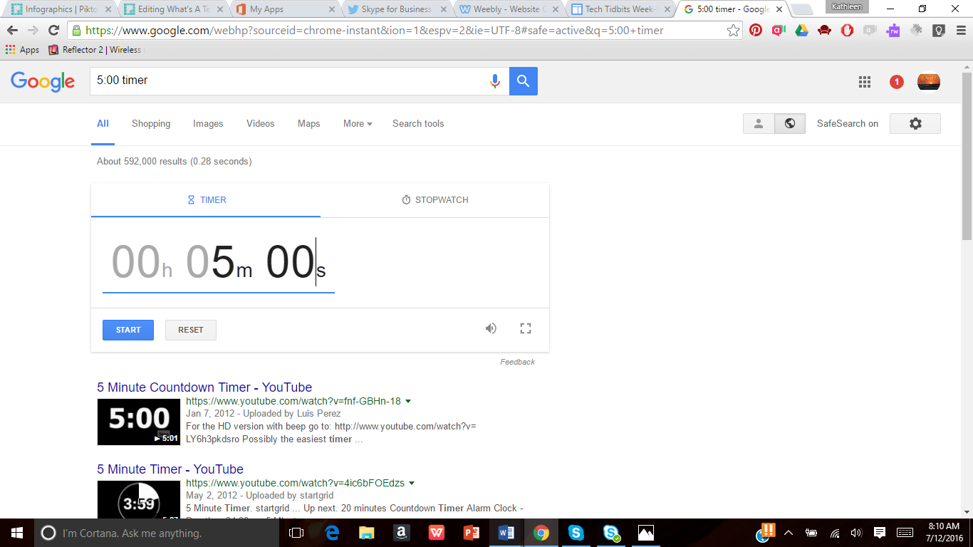

**Click here to go full screen with it so you can project it for the little darlings!**

Need a timer in a hurry? Go to Google and type in the amount of time you need and timer. For instance, type in 20 second timer and you will get timer at the top of the page!