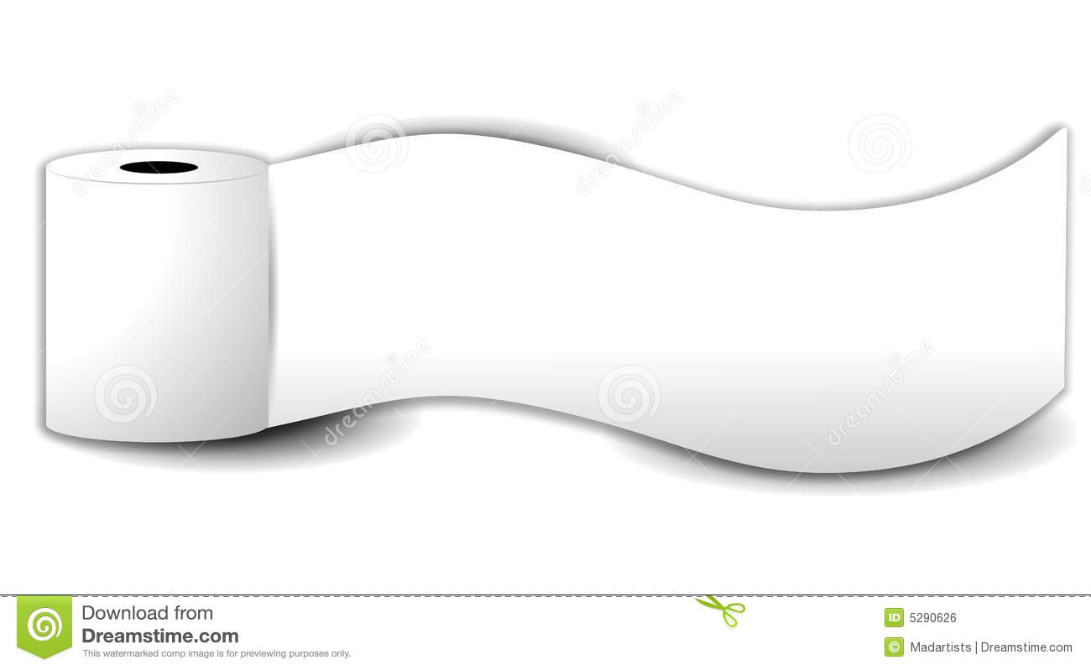

**#4**

**Learning in the Loo**

Did you know this handy little trick?

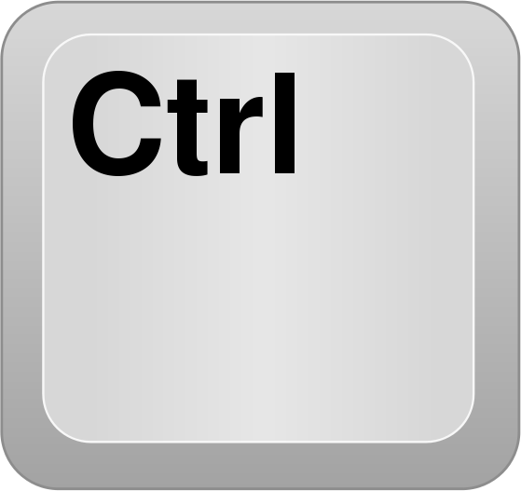  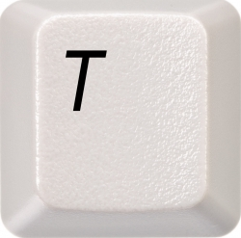

Control-Shift-T will reopen the last 10 tabs that have been closed in your Chrome browser?

So many times this will come in handy for so many reasons, right?

*(What a perfect teacher tip for when you walk past a student who nervously X’s out of something just as you approach…this might definitely be a trick you could use!)*