Install AdBlock (not Adblock Plus) –
it literally blocks ads on all web pages and is EXCELLENT to install on student computers!

You’ll see this little stop sign with a hand appear. It will stay there as a Chrome Extension. You can just X-out of this screen that is asking you to donate money.
Refresh the page you were originally on (that had ads) and you’ll see that the ads are now gone!

From now on, you’ll see notifications up there that indicate how many ads are being blocked on your page!

* By the way, this has to be done to each computer, and also each LOG IN on each computer. The Adblock doesn’t “hold” across users. Grades 2 and up, you can absolutely talk your students through this installation process so that you don’t have to do it 25 times!
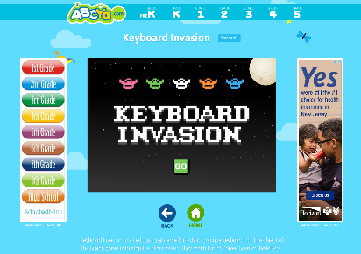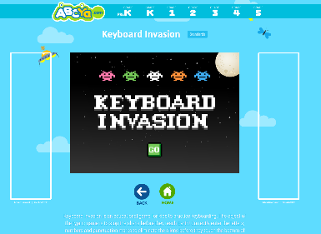
Before After

