Tips for image searches:
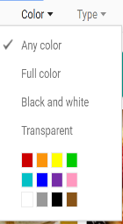
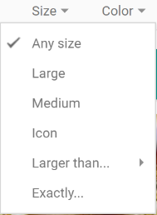
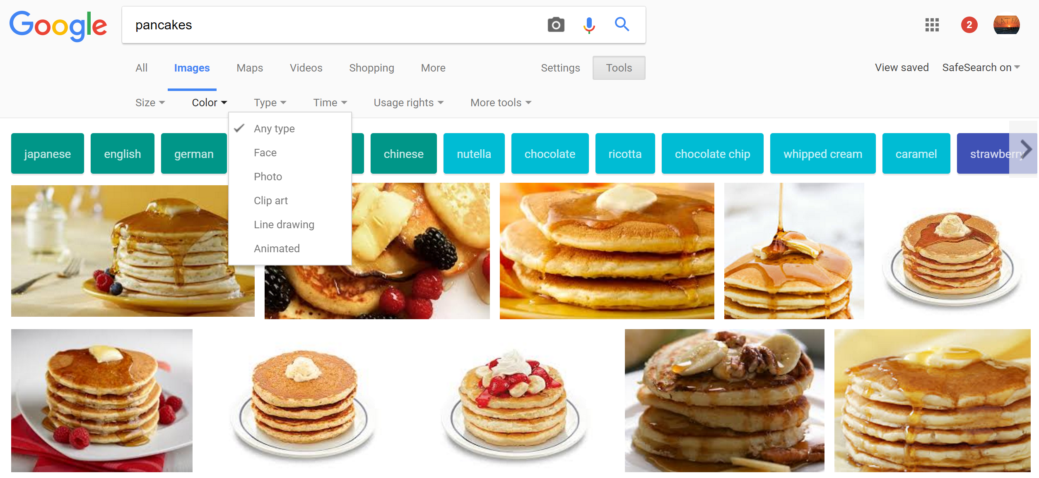
Next time you do a Google search, just type the word in the search bar & click on the word “images” like you always do. Then, check out the “tools” function – it lets you sort through the images by size, type, etc. Try using “transparent” when you choose a color – it doesn’t mean the IMAGE is transparent, it means the background is! (That’s my favorite and I use it all the time!)
Be brave and play around with some of those filters to find exactly what you need!

