Look for “The Snowman”! (3 vertical dots!)
Whenever you….Click on the three dots, you’re gonna see lots! Cool hidden stuff!
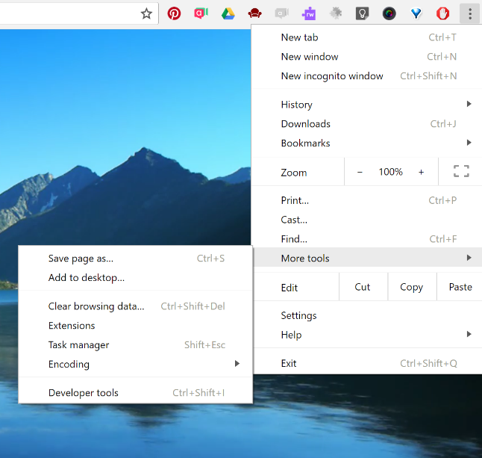
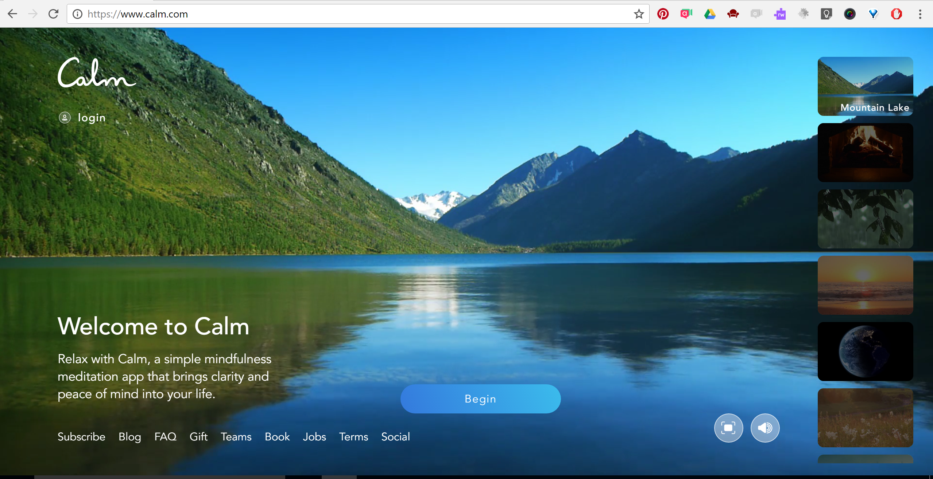
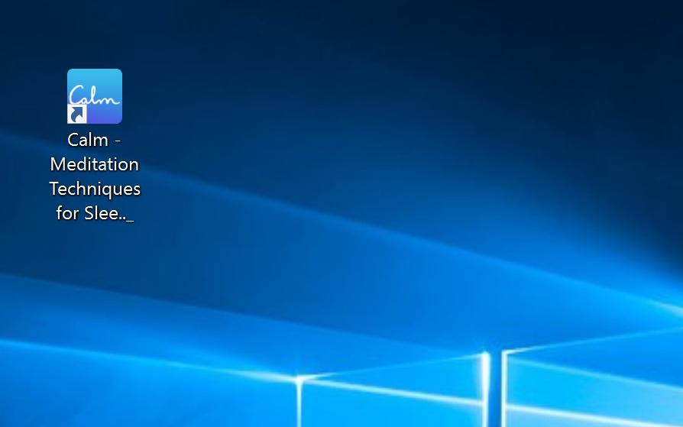

Check it out – I made a desktop shortcut icon of a site that I love to visit a lot! This works with ANY website! Really – try it! By the way, I purposely chose Calm.com for this example….BONUS! Teachers sooooooooo need this site!

